Epsom & Ewell
5
v
AFC Hayes / Farnham Town
Saturday, 21st September 2019 – 3.00 p.m.
Saturday, 28th September 2019 – 3.00 p.m.
Good afternoon and welcome to High Road for one of two Combined Counties League matches, depending on which day you are visiting, with AFC Hayes here on Saturday 21st September and Farnham Town here seven days later. We welcome the players, supporters and officials of both teams and hope they have a safe journey home.

We last hosted AFC Hayes in our final league match as a Premier Division club back on 28th April 2018, drawing 0-0; a result we have not seen since. Now, one season later, they join us in the lower tier. Farnham Town came down with us the previous season. They just missed out last season, although know that repeating last season’s fourth place finish will be good enough for promotion this season, due to the upcoming F.A. reorganisations. It is interesting to note that these two teams were our visitors for our final home fixtures of the last two seasons.

We were last here on the final day in August when we came up against a talented and hard-working Kennington team. I personally thought they pushed the boundaries a little and a stronger referee would have helped our case, yet it was us that finished a player short as we crashed 4-1. Since then, we visited Ash United on 7th September and repeated the previous season’s 2-1 win there with goals from Liam Roberts and Bobby Bennett, which placed us as high as fifth in the table at the time of writing, and a draw on Wednesday 18th September between Westside and Dorking Wanderers will keep us there, although any other result will mean we are sixth. We had no game last Saturday, although managed to fit in a friendly at Hanworth Villa on Tuesday 10th September where we drew 0-0 with a number of triallists on show.

Going forward, (or looking back, depending on which match you are here for today!) we are / were visiting Premier Division Sheerwater in the League Cup on Tuesday 24th September and after these two home fixtures we travel to Bedfont & Feltham on Tuesday 1st October when we commence our Division One League Cup campaign, knowing that we knocked the same opponents out last season on our way to the Final. We then follow that match with two further away trips, to a resurgent Cove on the Saturday and Chessington & Hook United seven days later. Our next home programme will be a larger one as we host FC Deportivo Galicia on Saturday 19th October and I will also be marking 100 years since our first ever competitive match in that programme.

Finally, we have been drawn at Sutton United Development in the First Round of the Surrey Premier Cup with a date to be advised, but likely to be midweek in October.

Enjoy the game!

Rich

You can follow us on social media – just see the inside cover for details.

Cover photo by Gemma Jarman

Liam Roberts scores our first goal in our 2-1 win
over Ash United on Saturday 7th September

Cherry Red Records Combined Counties League
Division One Table 2019/20
incl Tuesday 17th September | P | W | D | L | F | A | Pts | GD | H | A

Jersey Bulls | 7 | 7 | 0 | 0 | 31 | 2 | 21 | +29 | 13/4 | 16/11
Sandhurst Town | 7 | 5 | 1 | 1 | 17 | 8 | 16 | +9 | 9/11 | 14/3
Farnham Town | 5 | 4 | 0 | 1 | 15 | 6 | 12 | +9 | 28/9 | 15/2
British Airways | 7 | 3 | 2 | 2 | 15 | 13 | 11 | +2 | 11/1 | 29/2
Epsom and Ewell | 6 | 3 | 1 | 2 | 16 | 13 | 10 | +3 | x | x
Bedfont & Feltham | 6 | 3 | 1 | 2 | 11 | 8 | 10 | +3 | 14/12 | 18/4
Cove | 6 | 3 | 1 | 2 | 11 | 15 | 10 | -4 | 25/1 | 5/10
Kensington & Ealing Borough | 7 | 3 | 0 | 4 | 19 | 18 | 9 | +1 | 26/10 | 4/1
Fleet Spurs | 5 | 3 | 0 | 2 | 11 | 11 | 9 | 0 | 3-5 | 7/12
Westside | 6 | 2 | 1 | 3 | 11 | 8 | 7 | +3 | 28/12 | 3-1
Dorking Wanderers Reserves | 6 | 2 | 1 | 3 | 16 | 14 | 7 | +2 | 23/11 | 11/4
Walton & Hersham | 4 | 2 | 1 | 1 | 7 | 8 | 7 | -1 | 31/3 | 2/11
Chessington & Hook United | 6 | 2 | 1 | 3 | 9 | 11 | 7 | -2 | 22/2 | 12/10
Tooting Bec | 4 | 1 | 3 | 0 | 8 | 6 | 6 | +2 | 2-2 | 12/11
Ash United | 6 | 2 | 0 | 4 | 11 | 19 | 6 | -8 | 8/2 | 2-1
Bagshot | 6 | 2 | 0 | 4 | 7 | 17 | 6 | -10 | 4/4 | 1-2
AFC Hayes | 5 | 1 | 2 | 2 | 13 | 13 | 5 | 0 | 21/9 | 18/1
FC Deportivo Galicia | 7 | 1 | 2 | 4 | 5 | 21 | 5 | -16 | 19/10 | 1/2
Eversley & California | 6 | 1 | 0 | 5 | 5 | 13 | 3 | -8 | 21/3 | 21/12
Godalming Town | 6 | 0 | 1 | 5 | 10 | 24 | 1 | -14 | 5-2 | 30/11

Lucky Day? – 21st September
Played 16 - Won 5 Drawn 2 Lost 9 - For 26 Against 34 - PPG 1.06 - Poor
Our Club record against AFC Hayes (including Brook House)
Played 12 - Won 2 Drawn 4 Lost 6 - For 18 Against 20 - PPG 0.83 - Very Poor
Our Largest wins and losses against AFC Hayes (including Brook House)
12th April 2016 - W 7-0 - Combined Counties League Premier Division (A)
29th January 2005 - L 0-3 - Isthmian League Division Three (H)
AFC Hayes ‘ Last Visit
28th April 2018 - Drew 0-0 - Combined Counties League Premier Division

Lucky Day? – 28th September
Played 12 - Won 7 Drawn 1 Lost 4 - For 30 Against 20 - PPG 1.83 - Good
Our Club record against Farnham Town
Played 6 - Won 5 Drawn 0 Lost 1 - For 15 Against 9 - PPG 2.50 - Fantastic
Our Largest wins and losses against Farnham Town
14th November 2017 - W 3-0 - Combined Counties League Premier Division (H)
20th October 2018 - L 1-4 - Combined Counties League Division One (A)
Farnham Town’s Last Visit
27th April 2019 - Lost 1-2 - Combined Counties League Division One

Latest Results and Fixtures
Buildbase F.A. Vase First Qualifying Round – Saturday 31st August
Abingdon United | 1-0 | Eversley & California
AFC Hayes | 3-1 | Dunstable Town
Ash United | 1-2 | Badshot Lea
Bedfont & Feltham | 5-0 | Lutterworth Athletic
Clanfield 85 | 7-3 | Sandhurst Town
Cove | 0-1 | Fleet Spurs
Epsom & Ewell | 1-4 | Kennington
Farnham Town | 2-1 | Langney Wanderers
Forest Hill Park | 1-2 | Westside
Godalming Town | 2-1 | Hailsham Town
Hillingdon Borough | 3-2 | Sandhurst Town
Lancing | 2-0 | Chessington & Hook United
Rugby Borough | 2-1 | British Airways
Buildbase F.A. Vase First Qualifying Round – Sunday 1st September
Bagshot | 2-0 | Broadbridge Heath
Tooting Bec | 2-4 | Walton & Hersham
Combined Counties League – Tuesday 3rd September
FC Deportivo Galicia | 2-2 | Dorking Wanderers Reserves
Kensington & Ealing Borough | 2-3 | British Airways
Sandhurst Town | 1-2 | Cove
Combined Counties League – Saturday 7th September
Ash United | 1-2 | Epsom & Ewell
British Airways | 4-2 | Godalming Town
Chessington & Hook United | 0-2 | Cove
Dorking Wanderers Reserves | 4-5 | Kensington & Ealing Borough
Eversley & California | 0-2 | Tooting Bec
Farnham Town | 3-1 | Westside
Fleet Spurs | 1-2 | Bedfont & Feltham
Jersey Bulls | 7-1 | Bagshot
Sandhurst Town | 4-1 | FC Deportivo Galicia
Walton & Hersham | 2-1 | AFC Hayes
Buildbase F.A. Vase Second Qualifying Round – Saturday 14th September
AFC Hayes | 2-0 | London Tigers
Bedford | 0-4 | Bedfont & Feltham
Beckenham Town | 6-0 | Farnham Town
Milton Keynes Robins | 4-1 | Fleet Spurs
Raynes Park Vale | 4-1 | Walton & Hersham
Redhill | 4-3 | Bagshot
Rusthall | 2-1 | Godalming Town
Seaford Town | 2-0 | FC Deportivo Galicia
Westside | 3-2 | Bexhill United
Latest Results and Fixtures
Combined Counties League – Saturday 14th September
Kensington & Ealing Borough | 1-5 | Jersey Bulls
Combined Counties League – Wednesday 18th September
Westside | V | Dorking Wanderers Reserves
Combined Counties League – Saturday 21st September
Bagshot | V | Chessington & Hook United
Bedfont & Feltham | V | Sandhurst Town
Cove | V | Dorking Wanderers Reserves
Epsom & Ewell | V | AFC Hayes
Farnham Town | V | British Airways
Godalming Town | V | FC Deportivo Galicia
Jersey Bulls | V | Eversley & California
Kensington & Ealing Borough | V | Ash United
Tooting Bec | V | Fleet Spurs
Westside | V | Walton & Hersham
Combined Counties League Cup First Round – Tuesday 24th September
Egham Town | V | Raynes Park Vale
FC Deportivo Galicia | V | AFC Hayes
Godalming Town | V | CB Hounslow United
Spelthorne Sports | V | Chessington & Hook United
Combined Counties League Cup Second Round – Tuesday 24th September
Ash United | V | Bagshot
Cobham | V | Fleet Spurs
Farnham Town | V | Walton & Hersham
Frimley Green | V | Ascot United
Molesey | V | Kensington & Ealing Borough
Sandhurst Town | V | Cove
Sheerwater | V | Epsom & Ewell
Combined Counties League Cup First Round – Wednesday 25th September
Colliers Wood United | V | British Airways
Guildford City | V | Hanworth Villa
Tooting Bec | V | Bedfont & Feltham
Combined Counties League Cup Second Round – Wednesday 25th September
Westside | V | Southall
Combined Counties League – Saturday 28th September
AFC Hayes | V | Jersey Bulls
Ash United | V | Bedfont & Feltham
British Airways | V | Westside
Chessington & Hook United | V | Eversley & California
Dorking Wanderers Reserves | V | Bagshot
Epsom & Ewell | V | Farnham Town
Latest Results and Fixtures
Combined Counties League – Saturday 28th September
FC Deportivo Galicia | V | Walton & Hersham
Fleet Spurs | V | Kensington & Ealing Borough
Sandhurst Town | V | Godalming Town
Tooting Bec | V | Cove
Combined Counties League Cup First Round – Tuesday 1st October
Badshot Lea | V | Redhill
Esoteric Division One Cup – First Round – Tuesday 1st October
Ash United | V | British Airways
Bagshot | V | Walton & Hersham
Bedfont & Feltham | V | Epsom & Ewell
Kensington & Ealing Borough | V | Tooting Bec
Combined Counties League – Saturday 5th October
Bagshot | V | AFC Hayes
Bedfont & Feltham | V | Dorking Wanderers Reserves
Cove | V | Epsom & Ewell
Eversley & California | V | British Airways
FC Deportivo Galicia | V | Ash United
Fleet Spurs | V | Chessington & Hook United
Godalming Town | V | Tooting Bec
Jersey Bulls | V | Sandhurst Town
Walton & Hersham | V | Farnham Town
Westside | V | Kensington & Ealing Borough

Milestones
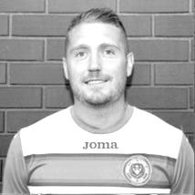
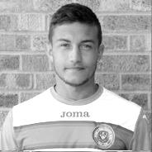
During the next few matches we have a couple of milestones that should occur, fitness permitting. I shall start with our Captain Scott Murphy who, if selected against AFC Hayes will make his 100th appearance for the club at Sheerwater on Tuesday 24th September and will become the 125th player in club history to reach this mark.

Scott joined us back in our very first Combined Counties League season of 2006/07 from Woking Academy and made 14 appearances before leaving, only returning some ten years later in 2017 during our unsuccessful battle against relegation.

Bobby Bennett joined us at the start of last season from Godalming Town and if he plays in the two matches listed above, would then make his 50th appearance against Farnham Town, becoming the 271st player in club history to do so. Bobby was last season’s Player of the Year and also our leading scorer, and of course scored our recent winner at Ash United.

Congratulations to both players!

From behind the goal
Epsom & Ewell 1-4 Kennington
Buildbase F.A. Vase - First Qualifying Round - Saturday 31st August 2019

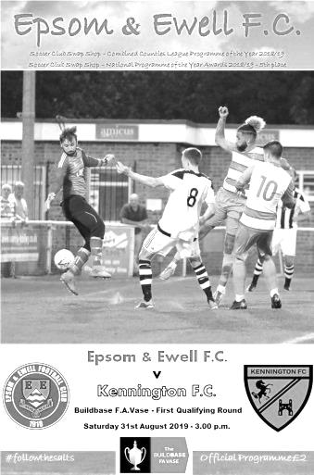
Vase dream dies in the usual manner

Over the last 44 years since reaching Wembley in the inaugural F.A. Vase Final, our success in the competition has been extremely limited and this dismal record continued on Saturday as we were well beaten by a hard-working and competitive Kennington side who closed us down throughout the match and denied us any real opportunity to start playing the football that we know we are capable of.

It must also be said that some of our opponents tactics were more physical than we are used to encountering and some stricter refereeing might have allowed the game to flow more, but judging by the way they were able to cut out the rough stuff in the second half, it's probably fair to put the first half excesses down to the exuberance of a team that were very keen, rather than cynical.

We fielded quite a strong side, with Rob Hendry coming back into the starting line-up as did Sean White, after missing Tuesday's match with new father duties. Bobby Bennett and Jordan Gallagher dropped to the bench for this one, but it was pleasing to see that the player reliability issues that haunted the end of last season, and threatened to derail the start of this one, now appear to be a thing of the past as our bench looks strong too these days.

What was more concerning however, was the way that we performed over the first 45 minutes. Yes, we had chances, as early as the 7th minute when a deep ball from Hendry was met at the far post with a looping header over the keeper by White, which was headed off the line by a covering defender. A couple of minutes later and from the first of many free kicks, Toby Funnell's strike was deflected just wide of the post by the defensive wall.

But these would prove to be isolated opportunities as we were hassled, harried, and often just knocked over as we tried to get into the game. We appeared unable to make space, which led to a number of passes across the field followed by a sixty yard pass that was not the sort of service that our strikers needed. We appeared short of options and when White lost possession on the edge of the Kennington area, the visitors broke away and Charlie Owen lobbed the exposed Felix Davies with the ball coming back off the outside of our post. The end result was a corner and we weren't alert to the short delivery and subsequent cross which found Gary Clarke in far too much space to guide his header past our keeper from eight yards in the 11th minute.

The visitors continued to battle for everything with varying degrees of legality and following a nasty foul on Scott Murphy that went unpunished, Hendry was then clattered, earning the first of what would only be two yellow cards awarded to Kennington in the first half; probably about three less than there should have been.

Chaz-Lee Martin was not far away with a header from an Adam Heagney corner before they hit our post once again; Tom Scorer curling the ball around a defender and being unfortunate to see the ball rebound into play with Davies beaten in the 34th minute. Incredibly, Martin then picked up a yellow card for what was about our first foul of the match; a slightly late collision that was more clumsy than malicious.

From yet another foul, we fed the ball out to Funnell on the right whose drilled effort was met by White just eight yards out, but his connection was mistimed and the ball dribbled harmlessly out for a goal kick.

Another Funnell shot was deflected wide as we began to build pressure in the closing minutes of the half and in the 43rd minute we were back level when a deep delivery was knocked back in to Smith and as the ball ran loose Heagney drilled the ball downwards and up into the net from around 12 yards.

There was just time for a visiting player to pick up yet another warning for going in studs up on Davies but the main thoughts at half time were that we had been lucky to be level at that point, and that surely the referee would get tougher with the visiting challenges. As it turned out, and is so often the case in our Vase matches, the tide turned against us within minutes of the second period commencing. We nearly conceded in the opening moments when Davies gave Heagney a hospital pass, and was robbed, although Davies made a smart stop from the shot to recover the situation.

However, in the 49th minute, Martin lost control of the ball and as he went to retrieve it, the ball was struck against his hand from no more than two yards out. Having had the benefit of viewing this replay on a few occasions, thanks to the excellent coverage from "Your Instant Replay" Martin's hand is moving towards the ball, but that is because his entire body is moving towards the ball at speed in an attempt to retrieve the ball. There is no way anyone can react that quickly to the ball being fired towards them, and there must have been clear doubt about this, especially seeing it just the once in real time as the referee did, yet he decided that the "offence" was worthy of a second yellow card. Despite knowing that this was a pivotal decision and would change the match, he chose to make it with no reference to an Assistant that had exactly the same view I had and chose to do nothing, because ultimately, there was nothing there to see, although in fairness, the Assistant had also ignored a high foot at the end of the previous half that had nearly taken Murphy's head off, despite him standing up at the time, so I can't be certain that he was properly watching.

With Martin off the field, we were really up against it, and two headers off the line only provided a temporary respite as the visitors re-took the lead in the 58th minute when a near post corner was tapped in easily by Clarke for his second goal of the match in the 58th minute. Our final chance came ten minutes later when a short Epsom corner was delivered to Hendry at the far post. His looping header over the keeper was knocked out by a defender on the line but the ball fell kindly to Murphy, whose volley was a good one, but struck the leg of a defender on the goal line and the ball was cleared.

Then in the 74th minute our time was up as Craig Calvert struck at goal from around 25 yards and he hit it like a fading golf drive, the ball spinning away from Davies' reach an nestling in the far corner of the net. It was a good strike and three minutes later Gary Lockyer put the finishing touch to a low right wing cross from close range to give Davies no chance. We could and probably should have been reduced to nine men in the closing seconds when a frustrated Roberts kicked out at a visiting player, but the referee appeared to give him the benefit of the doubt and kept him on the field. Pity he hadn't done that earlier in the match with Martin.

Kennington are a very good side and definitely the best team we have played this season. It must also be reported that they curbed their physical approach in the second half and played some very nice football, albeit against ten men. It would be harsh to blame just the referee for this result as we were second best on the day, and most certainly have some serious concerns to address, starting with why 14 of our 16 goals conceded this season have come in the second half and why we were unable to make as much space, but just when we had got back into the match, any opportunity we had was snuffed out by an extremely harsh decision and why is it that these sort of things always seem to happen to us in the Vase?

Fortunately, and for the first time in club history it could be argued, a Vase run, whilst exciting, is most definitely not our priority this season. That is to gain promotion and it should be stressed that a reorganisation of the divisions next season could leave us playing teams in the Kent area on a regular basis next season. We learned first hand on Saturday what that may prove to be like if we remain at Step Six for 2020/21.

Epsom & Ewell: Felix Davies, Adam Heagney, Joe Bonass-Ward, Jake Robinson, Chaz-Lee Martin, Lloyd Connelly, Toby Funnell, Scott Murphy (c), Taryn Smith, Sean White, Rob Hendry

Subs: Louis Chin for White (55), Bobby Bennett for Funnell (59), Liam Roberts for Smith (65)

From behind the goal
Ash United 1-2 Epsom & Ewell
Combined Counties League - Division One - Saturday 7th September 2019

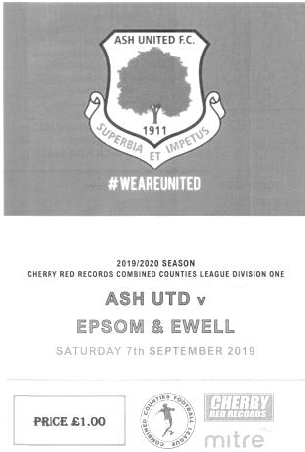
Late Bennett cameo rescues the points

On a superb looking playing surface at Ash United our boys took the three points on offer with a narrow win over their hosts. As always though, it wasn't easy and having done the hard work to get ahead, a late equaliser meant that we had to go and win the game again, not for the first time in recent weeks following matches against Westside and Godalming Town. It also maintained a record which now stands at 21 matches without a draw on that day in history!

We made some mostly enforced changes after the Kennington defeat as Lloyd Connelly was working, Rob Hendry was unavailable and Chaz-Lee Martin started a five match suspension, incurred for his two red cards in consecutive matches. Into the line-up came Louis Chin, Todd Murphy, Liam Roberts and Jordan Gallagher, with Sean White dropping to the bench and last season's leading scorer Bobby Bennett remaining there, although his performance in the final twenty minutes of this match will surely earn him a starting berth when we next play in fourteen days. Finally, Conor Young came into the line-up at short notice in goal, replacing the suspended Felix Davies, who had recently received a red card playing for the Woking Academy side.

It was Chin's first return to the starting eleven since the opening day of the season and he nearly marked it with a superb twenty-five yard strike with his supposedly weaker left foot, which whistled about a foot wide of the top corner as early as the sixth minute. It was apparent in this match that the Ash team did not possess the same energy that we had faced against Kennington the week before and we had more time to play in. This was particularly apparent on our right wing where Toby Funnell was often left in a lot of space, although the end product was lacking on most occasions. In fact, we lost the ball in that area in the 11th minute, leading to a swift counter attack, where Stan Staines got around the back of our defence, forcing Young into his first save of the match. We also had a fortunate escape in the 20th minute when a long ball over the top was cleared by Young, but the ball was struck straight at Chin and could have gone anywhere. Fortunately the ball went safe and Chin recovered after some treatment.

The next incident of relevance came in the 24th minute when Adam Heagney was shown a yellow card for a foul. However, whilst the Ash player certainly came off worse, it didn't look like a foul to me and you could tell by the player protests that this was the wrong decision. Regrettably, as happened seven days previously, this poor call would come back on us later on in the match.
Taryn Smith was the next player to have an opportunity as he was at the far post for a Heagney corner, but his volley was straight at the home keeper Aaron Lucas who was able to catch the ball. Funnell was next to have a try at goal, but the angle was a wide one and Lucas made the save from fifteen yards out. Once again, it was beginning to look like many matches of recent weeks where we were struggling to break the opponents down and the best chance of the half actually went to Ash on the half hour, after Staines had again got round the back of our defence, sending a low pass across goal to Joe Pantony, no more than eight yards out, but the left footer struck at goal with his right foot and saw his effort skim our post on its way out for a goal kick.

Joe Bonass-Ward was well positioned to clear away the next Ash attack after the ball had pinged about in our penalty area following a corner and as we broke Smith found Liam Roberts on the left who squared for Jake Robinson to shoot, but Lucas gathered the low strike at the second attempt. Robinson then ran onto a pass from Jordan Gallagher, but appeared to be caught from behind in the act of shooting, although no penalty was given. As the half ended Roberts was lucky not to end up with a booking for delaying the restart as he kicked the ball fully fifty yards across the pitch after being pulled up for an offside decision and it must be said that colleagues on the sideline confirmed that many offside calls both for and against us in the first half, were poor ones.

With both teams looking a bit light up front, it was clear that chances would be at a premium in the second half and Heagney was upended inches outside the penalty area, but Gallagher's free kick was deflected wide for a

corner. In response Pantony got behind our defence only for Young to stand up and make an important save. We then attacked again and Smith's shot was on target but deflected wide for a corner. Or so we thought. The Assistant didn't see the ball crossing the line and because it was so obvious, we hadn't even appealed, leading to a throw on being given a few seconds later, only for the referee to then decide that the ball actually had gone out of play, compounding the error by then awarding the hosts a goal kick instead! The Assistant would have more trouble over a throw in decision later in the match and it was clear that there was some serious inconsistency on display. That said, neither team to this point could say they were deserving of a higher standard themselves and the game, dare I say it, was beginning to drift towards a goalless draw.

So many times, you just have to throw in the mention of no goals, and within a minute one appears! A ball out to the left wing hopped up kindly for Roberts to nod the ball beyond his defender and he was through on goal, albeit from an angle. Lucas came out but, he neatly sidestepped him and drilled the ball low beyond a covering defender on the line to put us ahead in the 58th minute. We probably just deserved the lead at that point, but then started to sit back as if our work was done. Surely, without a clean sheet since last December we should know that one goal is never enough. In the 62nd minute from some pressure, a low Ash strike from just inside the area was turned wide by Young and we were beginning to lose our control of the midfield. Sam Morgan, deputising for our absent Manager Simon Funnell, made two key changes in the 71st minute that would turn the match back in our favour in due course, as White came on for Gallagher and Bennett came on for Funnell, both of whom upgraded our team as an attacking unit. It nearly worked straight away as Smith won the ball off a defender and fed Bennett whose shot from 12 yards was superbly tipped just wide by Lucas, but despite the added impetus of the substitutions Ash substitute Luke Cairns got away down the right, ran in on goal and drilled the ball past Young from about 15 yards for the equaliser in the 77th minute.

This was now the sixth league match in a row that we have led, yet been brought back to level terms and it is becoming frustrating. After doing the hard work, we now had to do it again. Fortunately this would now prove to be our best ten minutes of the match and we were straight away on the attack as Roberts found Smith on the left. his deep cross was just kept in play by Bennett who found White, but the ball was behind him and he was unable to direct his overhead kick on goal Within a minute Bennett found White again and his low shot on target was spilled by Lucas but then cleared away and in the 83rd minute Roberts cut inside and then laid the ball out for Smith to strike, although he spooned his shot over the bar from just inside the box.

There were still alarms at the other end though and Cairns broke through once more, but Young made a superb save low to his left and this would prove to be the match changer. We attacked again on the right and the challenge between player and keeper fell kindly for Bennett to run in on goal, draw the defender towards him and plant the ball into the vacant net from close range in the 85th minute to give us the lead for keeps. He then beat Lucas to a through ball two minutes later, but with just defenders to beat he was crowded out. In the spell of quarter of an hour he could have had a hat trick!

Bizarrely he even had time to pick up a booking for something he appeared to say, for which the referee chose to issue a card, yet not send him to the newly created sin bin. Consistency was becoming a real issue and when Heagney flicked the ball behind him after the home side had been awarded a free kick in the 91st minute, he was given a second yellow card and sent off! It was the most ludicrous decision, especially bearing in mind that Roberts had sent the ball to the far corner of the pitch just before half time without any more than a quick "don't do that again". Roberts then made his first visit to the sin bin in the final seconds, leaving us with nine men. This new rule is a farce and is made worse by poor and inconsistent decisions which confuses both sets of players, as it did in this match. It is no wonder that the players feel the need to speak out from time to time.

The whistle blew moments later and we had the three points in the bag. However, we need to start learning a few lessons, and it's better to learn them when you have three points than when you've just lost. Firstly, when you have an official who is clearly struggling, then say absolutely nothing to him or this shortage of players will cost us at some point very soon. Secondly, we must keep on the front foot once we have taken the lead. Sitting back is not working, especially when the opposition have worked out that they have more pace than you at the back, as they did in this match. Thirdly, we need to find a way to break through more consistently in the final third, which sounds silly if you had just witnessed the final ten minutes, when we showed we can do it when we need to, but if we could just start like that, we'd have some much easier afternoons. We are capable of finishing in the top four right now, and currently sit in fifth place with all to play for. Is that a false position? Time will tell.

Epsom & Ewell: Conor Young, Louis Chin, Joe Bonass-Ward, Adam Heagney, Todd Murphy, Jake Robinson, Toby Funnell, Scott Murphy (c), Taryn Smith, Jordan Gallagher, Liam Roberts

Subs: Bobby Bennett for Funnell (71), Sean White for Gallagher (71)

EL Records Premier Challenge Cup
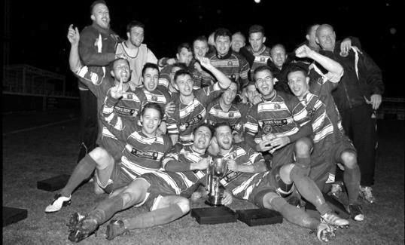
First Round
Guildford City | 25/9 | Hanworth Villa
Eversley & California | 24/9 | Balham
Tooting Bec | 24/9 | Bedfont & Feltham
FC Deportivo Galicia | 24/9 | AFC Hayes
Badshot Lea | 1/10 | Redhill
Colliers Wood United | 25/9 | British Airways
Egham Town | 24/9 | Raynes Park Vale
Spelthorne Sports | 24/9 | Chessington & Hook United
Godalming Town | 24/9 | CB Hounslow United
Second Round
Ash United | 24/9 | Bagshot
Westside | 25/9 | Southall
1 | V | Jersey Bulls
Abbey Rangers | V | 7
9 | V | 2
Camberley Town | V | 6
3 | V | Knaphill
Frimley Green | 24/9 | Ascot United
Sutton Common Rovers | V | 8
Sandhurst Town | 24/9 | Cove
Banstead Athletic | V | 4
Molesey | 24/9 | Kensington & Ealing Borough
Cobham | 24/9 | Fleet Spurs
5 | V | Dorking Wanderers Reserves
Sheerwater | 24/9 | Epsom & Ewell
Farnham Town | 24/9 | Walton & Hersham

EL Records Division One Challenge Cup Draw
First Round
Kensington & Ealing Borough | 1/10 | Tooting Bec
Ash United | 1/10 | British Airways
Bedfont & Feltham | 1/10 | Epsom & Ewell
Bagshot | 1/10 | Walton & Hersham
Second Round
Dorking Wanderers Reserves | 22/10 | Jersey Bulls
Sandhurst Town | 22/10 | Chessington & Hook United
Ash United /  British Airways | 22/10 or 23/10 | Bedfont & Feltham /  Epsom & Ewell
Godalming Town | 22/10 | Farnham Town
Cove | 22/10 | FC Deportivo Galicia
Fleet Spurs | 22/10 | Westside
Bagshot /  Walton & Hersham | 22/10 | AFC Hayes
Kensington & Ealing Borough / Tooting Bec | 22/10 | Eversley & California

Our Club Statistical History - (inc Saturday 7th September):
All League: Played: 2,963, Won: 1,214, Drawn: 564, Lost: 1,185
For: 5,456, Against: 5,273, GD: + 183 - Win Ratio 40.97%

Combined Counties League: Played: 542, Won: 239, Drawn: 106, Lost: 196
For: 990, Against: 887, GD: + 103 - Win Ratio 44.28%

Cup and Other: Played: 1,131, Won: 536, Drawn: 130, Lost: 457
For: 2,455, Against: 2,118, GD: + 337 - Win Ratio 47.39%

Abandoned Matches: Played: 8: For: 14, Against: 16

Under Simon Funnell: Played 40, Won: 20, Drawn: 5, Lost: 15
For: 93, Against: 79, GD: + 14 - Win Ratio 50.00%

Overall: Played 4,094, Won: 1,750, Drawn: 694, Lost: 1,642, Abandoned: 8
For: 7,911, Against: 7,391, GD: + 520 - Win Ratio 42.75%

For the purposes of these records, all matches that resulted in penalty shoot outs are recorded as draws, regardless of whether they were won or lost.

This Day in History – 21st September
Date | Day | Competition |  | Opponents |  | Scorers
21/09/29 | Sat | F.A. Cup  Preliminary Round | H | Beddington Corner | 8-3 | R.Marlow (4), R.Stimson (2), F.Behn, W.Challis
21/09/35 | Sat | F.A. Cup  Preliminary Round | H | Met Police | 1-1 | G.Milnes (pen)
21/09/46 | Sat | F.A. Cup  Preliminary Round | H | Met Police | 0-5
21/09/57 | Sat | Corinthian League | A | Dagenham | 1-3 | J.Bangs
21/09/63 | Sat | Surrey Senior Cup 1q | A | Met Police | 1-3 | G.Whooley
21/09/68 | Sat | F.A. Cup 1q | A | Tilbury | 0-1
21/09/74 | Sat | Surrey Senior Cup 1q | A | Molesey | 2-1 | J.Eales, T.Tuite
21/09/77 | Wed | F.A. Cup 1q replay | A | Feltham | 1-2 | A.Webb
21/09/85 | Sat | Isthmian League  Premier Division | A | Windsor & Eton | 1-2 | C.Miles
21/09/88 | Wed | Isthmian League 2s | A | Flackwell Heath | 1-3 | R.Kidd
21/09/91 | Sat | Isthmian League 3 | H | Clapton | 3-1 | M.Pepper, S.Alldridge, A.Skeet
21/09/96 | Sat | Isthmian League 3 | H | Kingsbury Town | 1-1 | M.Jones
21/09/99 | Tue | Isthmian League  Cup 1 replay | A | Staines Town | 0-3
21/09/02 | Sat | Isthmian League 1s | H | Leatherhead | 2-1 | K.Webb, R.Power (pen)
21/09/10 | Tue | Combined Counties League Cup 1 | A | Cove | 2-1 | M.Jarman, T.Cuff
21/09/13 | Sat | F.A. Vase 2q | H | Whyteleafe | 2-3+ | K.Hough (2)
Historical Decades
Date | Day | Competition |  | Opponents |  | Scorers
90 years ago – Epsom Town F.C.
21/09/29 | Sat | F.A. Cup  Preliminary Round | H | Beddington Corner | 8-3 | R.Marlow (4), R.Stimson (2), F.Behn, W.Challis
70 years ago – Epsom F.C.
17/09/49 | Sat | F.A. Cup  Preliminary Round | H | Cobham | 4-2 | B.Cutter (2), J.Collins, F.Marshall
60 years ago – Epsom F.C.
19/09/59 | Sat | Corinthian League | A | Horsham | 1-2 | J.Bangs
50 years ago – Epsom & Ewell F.C.
20/09/69 | Sat | F.A. Cup 1q | H | Tilbury | 0-1
40 years ago – Epsom & Ewell F.C.
18/09/79 | Tue | Isthmian League 1 | A | Camberley Town | 0-2
30 years ago – Epsom & Ewell F.C.
19/09/89 | Tue | Isthmian League 2s | A | Bracknell Town | 3-0 | B.Perkins, G.Smith, A.Van Sliedregt
20 years ago – Epsom & Ewell F.C.
21/09/99 | Tue | Isthmian League  Cup 1 replay | A | Staines Town | 0-3
10 years ago – Epsom & Ewell F.C.
22/09/09 | Tue | Combined Counties League Cup 1 | H | Wembley | 3-0 | M.Jarman, D.Marvell,  R.Bedj Bedj
History Corner – 21st September
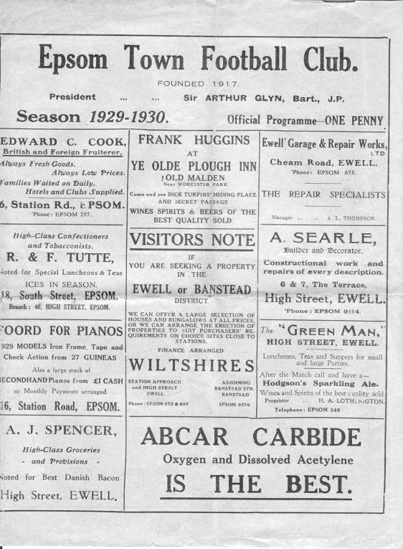
90 years ago today we hosted Beddington Corner in an F.A. Cup tie and won 8-3. (see programme right) The local papers advised that there was “a gulf of difference between the sides" and Reg Marlow scored four times and Reg Stimson got two, while Welsh Amateur International Herbert Etheridge was our new Captain, having joined from Dulwich Hamlet. We would have a decent run this year, defeating Dorking and Mitcham Wanderers before crashing out at Wimbledon in front of just under 7,500 spectators. Hard to believe now, isn’t it!

17 years ago today we defeated Leatherhead 2-1 in our latest Isthmian League match. We had been recently promoted to the Division One South and had set a blistering pace with five wins and a draw before picking up another three points here to go to the top of the table. Kevin Webb had put us ahead at first, but this was a match with two highly suspicious penalties, firstly against us as the visitors scored their equaliser, and then in our favour for a very harsh handball decision, which ultimately gave us the points through a Ray Power penalty. (see programme left)
6 years ago today we had our third meeting with Whyteleafe and they weren’t even in the same division as us! We had already been drawn together in the F.A. Cup when a solid 3-3 away draw had been followed by a total disaster as we crashed 6-1 in the replay, with future player Taylor Smith scoring a hat trick for them in fifteen minutes. This time it was a meeting in the F.A. Vase and we led for over an hour after Kyle Hough had put us ahead, but a late equaliser forced extra time and although we scored late on through Hough again, we had already conceded two more goals and lost 3-2 in the end.

They were a good side though and would go up as Champions of the Kent League that year, while we managed a third place finish of our own; our highest since 1983/84.

Centre page for results

Centre page for results

First Eleven Appearances - (max 7)
Name | Debut | 2018/19 |  |  |  | Career Totals
 |  | App | Sub | Tot | Goals | App | Sub | Tot | Goals
BENNETT Bobby | 12/08/2018 | 3 | 3 | 6 | 3 | 44 | 3 | 47 | 26
BONASS-WARD Joe | 10/08/2019 | 6 | 0 | 6 | 0 | 6 | 0 | 6 | 0
CARNEY Billy | 12/01/2019 | 1 | 2 | 3 | 2 | 13 | 7 | 20 | 8
CARTON Kyle | 03/08/2019 | 1 | 0 | 1 | 0 | 1 | 0 | 1 | 0
CHIN Louis | 08/12/2018 | 2 | 1 | 3 | 0 | 15 | 2 | 17 | 0
CONNELLY Lloyd | 14/10/2017 | 6 | 0 | 6 | 1 | 84 | 4 | 88 | 7
DAVIES Felix | 03/08/2019 | 6 | 0 | 6 | 0 | 6 | 0 | 6 | 0
FUNNELL Toby | 03/08/2019 | 7 | 0 | 7 | 0 | 7 | 0 | 7 | 0
GALLAGHER Jordan | 07/08/2016 | 6 | 0 | 6 | 2 | 55 | 13 | 68 | 20
HEAGNEY Adam | 16/08/2016 | 5 | 0 | 5 | 1 | 119 | 13 | 132 | 4
HENDRY Rob | 08/08/2015 | 2 | 3 | 5 | 2 | 112 | 27 | 139 | 48
LEWIS Rory | 03/08/2019 | 1 | 1 | 2 | 0 | 1 | 1 | 2 | 0
MARTIN Chaz-Lee | 03/08/2019 | 5 | 0 | 5 | 2 | 5 | 0 | 5 | 2
MURPHY Scott | 20/01/2007 | 5 | 0 | 5 | 1 | 96 | 2 | 98 | 10
MURPHY Todd | 27/11/2018 | 2 | 0 | 2 | 0 | 5 | 9 | 14 | 0
NIGHTINGALE Zak | 03/08/2019 | 0 | 1 | 1 | 0 | 0 | 1 | 1 | 0
ROBERTS Liam | 12/08/2017 | 2 | 5 | 7 | 2 | 52 | 26 | 78 | 19
ROBINSON Jake | 23/02/2019 | 6 | 0 | 6 | 0 | 15 | 1 | 16 | 0
SMITH Taryn | 28/10/2017 | 6 | 0 | 6 | 1 | 20 | 11 | 31 | 6
SULLIVAN Ryan | 04/08/2018 | 1 | 0 | 1 | 0 | 31 | 2 | 33 | 0
THOMPSON Ashley | 21/08/2017 | 1 | 0 | 1 | 0 | 36 | 1 | 37 | 5
WHITE Sean | 02/08/2014 | 2 | 2 | 4 | 0 | 31 | 27 | 58 | 9
YOUNG Conor | 07/03/2015 | 1 | 0 | 1 | 0 | 62 | 0 | 62 | 0

AFC Hayes – History
The club was formed in 1974, springing from local Saturday sides Charville and Hayes North.

Success soon followed in the lower divisions of the Hayes and District Sunday League culminating in winning the Middlesex Sunday Junior Cup. Success continued with two League and Cup winning doubles before a switch to Saturday football in 1982 joining the now defunct South West Middlesex League.

Brook House then became founder members of The Middlesex County League before they joined the London Spartan League in 1989 when they were awarded senior status. In their first season, despite not finishing in one of the two promotion spots they were promoted to the Premier Division.

In 1992 the club had their floodlights erected, and to mark the occasion, Chelsea were the first opponents under lights at Farm Park. In the same season, the final of the Spartan League Cup was reached, but Cheshunt took the trophy.

With the advent of their lights, the club was able to enter the FA Cup, and on two occasions they have reached the first qualifying round, most notably in 1995/96 when they held Conference side Stevenage Borough to a 0-0 draw away only to lose the replay at home.

In 1999/2000 the club were runners up in the Premier Division of The Spartan South Midlands League and were Premier Division Cup winners. The reserve side won the Middlesex County League and Cup double and gained entry to The Suburban League for season 2000/01.

The following season they won their geographical division and were promoted to The Premier Division. At the end of the 2001/02 season, manager Mickey Harvey decided to try pastures new, with Bob Strutton taking over.

2003/04 saw all the hard work and belief in younger players pay off, and we were never out of the top three in the league, eventually achieving second place. The lads also won the Challenge Trophy and were runners - up in the Premier Cup. Having just missed out promotion to the new National Step Four, we were invited into the Ryman Isthmian League Division Two.

In the close season, Bob decided to call it a day, so the Club again promoted from within. Joe Mitchell as manager with Colin Murphy as assistant and head coach.

2004/05 was a very good year - 3rd in the league and last 16 of the FA Vase, and In 2005/06 we won the last ever Isthmian League Associate Members Trophy beating Hertford 3 - 1 in the final. In the League we eventually finished third on goal difference behind Ware and Witham Town, but that placing and the E Level ground -grading saw us promoted to the newly -formed Step 4 Level and into The Southern League South & West Division.

After a promising start to the season we had a very indifferent second half, but we managed to achieve our main ambition of staying at this level. The highlight was coming runners-up in the Middlesex Senior Charity Cup.

From 2007-2008 the club started with the new name for our senior sides AFC HAYES. The Youth section still carries on our historic club name.

The 2008/09 Season was the most successful season to date and the team finished 7th in the Southern League. This was overshadowed by winning the Middlesex Senior Cup for the very first time in the club's history as a 2-0 win over Hendon brought the trophy back to Farm Park.

During the next few seasons AFC Hayes consolidated in the Southern League and challenged for the Division One Central play-offs in 2011-12.

In 2012-13 we appointed Ian Crane. He was joined by Graham Goode as Assistant but on in early December 2014 Graham left us followed by Ian’s resignation after xmas 2014. We appointed Paul Palmer and his assistant Colin Brown quickly, hoping to turn it around but that didn’t happen he did not have enough time and relegation was the result and a place in the Combined Counties Football League Premier Division.

After an indifferent season some good and bad results we agreed to part company in November 2016 and Sean Berry a well-known local player took on the role as Manager until with assistant Alan Galloway. Both Sean and Alan Galloway continued into Season 2017-18 with Sean resigning early season. We then appointed Galloway and Dave Kennedy as joint managers for the remainder of the season where we finished in a disappointing position.

Allan Galloway was appointed manager for season 2018-19 and has brought in Terry Scholes, a well-known figure in local football as his assistant and James White also joined the staff along with the evergreen Terry Welch.

Farnham Town – History
Farnham Town Football Club is a senior level football club based In Farnham, Surrey, England.

Established in 1906 through the merging of Farnham Bungs (the Farnham Brewery) and the Farnham Star. The club was one of the founder members of the London Spartan League in 1975. They reached the Fourth Round of the FA Vase in the 1976-77 season.

At the end of the 1979/80 season Farnham Town left the London Spartan League and applied to the Combined Counties League, their application was accepted and they finished 4th in their first season. The 1986/87 season saw Farnham take second place to Ash United in the league campaign. The glory days finally arrived in the 1990/91 season when the club won the league title. In the 1991/92 season, the Town got a clean sweep of the major trophies by winning the Combined Counties Premier League, the Dan Air Elite Cup and the Dan Air Challenge Cup. Having won the league, the club applied and were accepted to the Isthmian League. However funds for necessary ground improvements could not be generated which resulted in the club not having a league to play in for the 1992/93 season.

In 1993/94 Farnham Town were accepted back into the Combined Counties League where they continue to ply their trade. From 1995-1998 Farnham finished in the top six of the Premier Division for three consecutive seasons, in 1998-99 they finished in 13th position, then 10th in 1999-2000 before suffering relegation from the Premier Division in 2000-2001 season. They bounced straight back the following season but then endured four tough seasons back in the Premier Division, with bottom four finishes every season culminating in relegation back down to Division One in 2005-2006. Again, the club bounced straight back and in 2006-2007 they won the Division One title under the guidance of Barry Bridger, but were denied promotion due to the Memorial Ground not meeting the desired grading by the league. The club then spent another four seasons in Combined Counties Division One.

Farnham gained promotion from Combined Counties Division One in the 2010-2011season after finishing second behind Worcester Park. In Paul Tanner’s first season at the helm he gained automatic promotion back to the Premier Division at the first attempt, which after only retaining four members of the side from the previous year’s squad - who finished mid-table, was quite an achievement.

Paul Tanner’s side also won the Combined Counties Fair Play Award for 2010-2011 after going the whole season without having a man sent off, a record to be proud of. In a very successful year for the club on the whole, Dean Nelson’s reserve side finished second behind Mole Valley in the Combined Counties Reserve Division, improving on fourth position the previous season. Farnham Ladies also finished second in their respective league to cap quite a remarkable season in Geoff Chapple’s final season as Chairman. In 2011, Ray Bridger took over as chairman from Geoff Chapple.

2017/18 didn’t go well for the club and Tanner left his role towards the end of a season that left them at the foot of the table, alongside Epsom & Ewell and Godalming Town and Dan Turkington took on the position with a brief of gaining promotion for 2018/19 but were only able to finish fourth..

Surrey Premier Cup
2018/19 Holders: Lingfield
First Round
Bagshot | V | Horley Town Reserves
Met Police Reserves | V | Cobham Development
Godalming Town | V | Dorkinians
Sutton United Development | V | Epsom & Ewell
Reigatians | V | Chessington & Hook United
Carshalton Athletic U21 | V | Walton & Hersham
Old Wilsonians | V | Westfield Reserves
Ash United | V | AFC Croydon Athletic Development
FC Deportivo Galicia | v | Dorking Wanderers Reserves
Byes to Second Round (7)
Westside
Abbey Rangers Development
Sutton Common Rovers U23
Nottsborough
Farnham Town
Molesey Development
Lingfield Reserves
We open up our Surrey Premier Cup campaign with a trip to Gander Green Lane to face the Sutton United Development XI. The match is scheduled to be played at some point in October.

To be honest, this is an incredibly uninspiring competition, rather strangely titled by the Surrey FA as the Surrey Saturday Premier Cup, even though 90% of the matches are played midweek! Being considered at the same level as some teams Reserve outfits, not that long after we were battering their first teams (AFC Croydon Athletic) is reason in itself to get back to the Senior version of this competition as soon as possible.

CCL Division One Club Directory
AFC HAYES: Telephone: 0208 845 0110 - Colours: Blue and White Stripes/Blue/Blue
Ground: Farm Park, Kingshill Avenue, Hayes, Middx. UB4 8DD

ASH UNITED: Telephone: 01252 344264 - Colours: Green with Red Trim/Green/Green
Ground: Shawfields Stadium, Youngs Drive, Shawfields Road, Ash, Aldershot. GU12 6RE

BAGSHOT: Telephone: 01252 623804 - Colours: Yellow/Black/Black
Ground: Camberley Town FC – Krooner Park, Wilton Road, Camberley. GU15 2QW

BEDFONT & FELTHAM: Telephone: 0208-890 7264 - Colours: Yellow/Blue/Blue
Ground: The Orchard, Hatton Road, Bedfont. TW14 9QT

BRITISH AIRWAYS: Telephone: 0208-890 7264 - Colours: Sky Blue/Navy Blue/Navy Blue
Ground: Bedfont & Feltham FC - The Orchard, Hatton Road, Bedfont. TW14 9QT

CHESSINGTON & HOOK UNITED: Telephone: 01372-602263 Colours: All Blue
Ground: Chalky Lane, Chessington. KT9 2NF

COVE: Telephone: 01252 543615 Colours: Yellow/Black/Black
Ground: Oak Farm, Squirrel Lane, Cove GU14 8PB

DORKING WANDERERS RES Telephone: 01306 400151 - Colours: Red & White Stripes/ Blue/ Red
Ground: Meadowbank Stadium, Mill Lane, Dorking. RH4 1DX

EPSOM & EWELL Telephone: 01737-553250
Colours: Royal Blue & White Hoops/Royal Blue/Royal Blue
Ground: Chipstead FC, High Road, Chipstead. CR5 3SF

EVERSLEY & CALIFORNIA Telephone: 0118 973 2400 - Colours: - White & Royal Blue Hoops /Royal Blue/ Royal Blue - Ground: Fox Lane, off Reading Road, Eversley. RG27 0NS

FARNHAM TOWN Telephone: 01252 715305 - Colours: - Claret & Sky Blue /White/ Claret & Blue
Ground: Memorial Ground, Babbs Mead, West Street, Farnham. GU9 7DY

FC DEPORTIVO GALICIA Telephone: 0208 831 9067 - Colours: Royal Blue/Royal Blue/White
Ground: Bedfont Sports FC - Bedfont Sports Club, Hatton Road, Bedfont. TW14 9JR

FLEET SPURS Telephone: 01252 662810 - Colours: Dark Blue with Red Trim/Dark Blue/Dark Blue
Ground: Kennels Lane Farnborough. GU14 0ST

GODALMING TOWN Telephone: 01483 417520 - Colours: Yellow/Green/Yellow
Ground: Wey Court, Meadrow, Godalming. GU7 3JE

JERSEY BULLS Telephone: 01534 449615 - Colours: Red and White
Ground: Springfield Stadium, Janvrin Road, St Helier, Jersey. JE2 4LF

KENSINGTON & EALING BOROUGH Telephone: 01372 360151 - Colours: All Blue
Ground: Leatherhead FC – Fetcham Grove, Guildford Road, Leatherhead. KT22 9AS

SANDHURST TOWN Telephone: 01252 878768 - Colours: Red & Black Stripes/Black/Black
Ground: Bottom Meadow, Sandhurst Memorial Park, Yorktown Road, Sandhurst. GU47 9BJ

TOOTING BEC Telephone: tba - Colours: Black & White Stripes/White/White & Black
Ground: Tooting & Mitcham United FC - Imperial Fields, Bishopsford Road, Morden, Surrey SM4 6BF

WALTON & HERSHAM Telephone: 07969 068731 - Colours: All Red
Ground: Elmbridge Excel Sports Hub, Waterside Drive, Walton-on-Thames. KT12 2JP

WESTSIDE Telephone: 01372-602263 - Colours: Yellow/Blue/Blue
Ground: Chessington & Hook United - Chalky Lane, Chessington. KT9 2NF

Results Grid
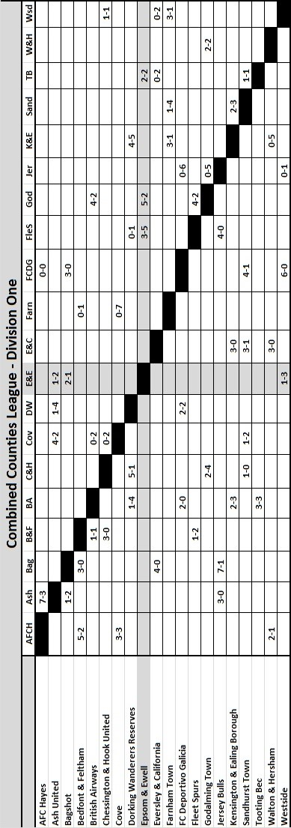

Combined Counties League Division One
Opponents All-time Records
inc 7th September 2019 | P | W | D | L | F | A | PPG | GD | Best  Win | Worst  Loss
Westside | 1 | 1 | 0 | 0 | 3 | 1 | 3.00 | +2 | 3-1 | -
Bedfont & Feltham | 5 | 4 | 1 | 0 | 25 | 12 | 2.67 | +13 | 9-2 | -
Godalming Town | 7 | 6 | 0 | 1 | 20 | 11 | 2.57 | +9 | 5-1 | 0-3
Bagshot | 4 | 3 | 0 | 1 | 12 | 3 | 2.25 | +9 | 7-1 | 1-2
FC Deportivo Galicia | 3 | 2 | 0 | 1 | 7 | 4 | 2.00 | +3 | 3-0 | 0-2
Ash United | 22 | 12 | 4 | 6 | 52 | 33 | 1.82 | +19 | 6-0 | 0-3
Cove | 36 | 17 | 9 | 10 | 80 | 58 | 1.67 | +22 | 7-0 | 1-6
Farnham Town | 19 | 9 | 4 | 6 | 32 | 31 | 1.63 | +1 | 3-0 | 1-4
Chessington & Hook | 30 | 13 | 9 | 8 | 63 | 45 | 1.60 | +18 | 6-0 | 1-3
Walton & Hersham | 54 | 25 | 11 | 18 | 105 | 105 | 1.59 | 0 | 8-0 | 0-8
Dorking Wanderers Res | 2 | 1 | 0 | 1 | 6 | 5 | 1.50 | +1 | 3-0 | 3-5
British Airways | 2 | 1 | 0 | 1 | 5 | 5 | 1.50 | 0 | 3-2 | 2-3
Eversley & California | 2 | 1 | 0 | 1 | 2 | 2 | 1.50 | 0 | 1-0 | 1-2
Fleet Spurs | 3 | 1 | 1 | 1 | 7 | 8 | 1.33 | -1 | 3-2 | 3-5
Tooting Bec | 3 | 1 | 1 | 1 | 6 | 7 | 1.33 | -1 | 3-1 | 1-4
Sandhurst Town | 17 | 7 | 0 | 10 | 29 | 31 | 1.24 | -2 | 4-0 | 1-3
AFC Hayes  (inc Brook House) | 12 | 2 | 4 | 6 | 18 | 20 | 0.83 | -2 | 7-0 | 0-3
Kensington Borough | 2 | 0 | 1 | 1 | 2 | 6 | 0.50 | -4 | - | 1-5
Jersey Bulls | 0 | 0 | 0 | 0 | 0 | 0 | - | 0 | - | -

This Day in History – 28th September
Date | Day | Competition |  | Opponents |  | Scorers
28/09/29 | Sat | Surrey Charity Shield 1 | A | Mitcham Wanderers | 1-2 | W.Challis
28/09/35 | Sat | London League | H | Eton Manor | 6-3 | H.Pullen (3), J.Jones, G.Collins, L.Graves
28/09/46 | Sat | Friendly | H | Tottenham Hotspur XI | 3-5 | F.Chitty, S.Scott (pen), K.Holliday
28/09/57 | Sat | Amateur Cup Preliminary Round | A | Vickers | 7-0 | D.Hermitage (4), J.Sorensen, J.Bangs, B.Pickard
28/09/63 | Sat | Amateur Cup Preliminary Round | A | Molesey | 0-2
28/09/68 | Sat | Amateur Cup Prelim Round replay | H | Molesey | 1-0+ | K.Jolly
28/09/74 | Sat | Surrey Senior League | A | Cobham | 4-1 | D.Ritman (pen), T.Tuite, J.Eales, T.Lee (pen)
28/09/85 | Sat | Isthmian League Premier Division | A | Hendon | 0-3
28/09/91 | Sat | Isthmian League 3 | A | Kingsbury Town | 1-1 | S.Alldridge
28/09/92 | Mon | Isthmian League 3 | A | Tring Town | 2-1 | R.Dymond (pen), R.Purvis
28/09/05 | Wed | Associate Members  Trophy Group Match | H | Camberley Town | 2-1 | D.Marvell, L.Gay
28/09/13 | Sat | Combined Counties Premier Division | A | Windsor | 3-1 | K.Hough (2, 1 pen), M.Jarman
Historical Decades
90 years ago – Epsom Town F.C.
28/09/29 | Sat | Surrey Charity Shield 1 | A | Mitcham Wanderers | 1-2 | W.Challis
70 years ago – Epsom F.C.
01/10/49 | Sat | F.A. Cup 1q | A | Woking | 2-1 | D.Ralph (pen), B.Cutter
60 years ago – Epsom F.C.
26/09/59 | Sat | Amateur Cup Preliminary Round | A | Worcester Park | 3-0 | J.Bangs (2), J.Sorensen
50 years ago – Epsom & Ewell F.C.
27/09/69 | Sat | Amateur Cup Prelim Round replay | H | Lion Sports | 1-0 | T.Seymour
40 years ago – Epsom & Ewell F.C.
29/09/79 | Sat | Isthmian League 1 | A | St Albans City | 0-4
30 years ago – Epsom & Ewell F.C.
26/09/89 | Tue | Isthmian League 2s | H | Abingdon Town | 3-0 | B.Perkins (2), P.Andrews
20 years ago – Epsom & Ewell F.C.
25/09/99 | Sat | F.A. Vase 2q | A | Tunbridge Wells | 2-1 | S.Miller (2)
10 years ago – Epsom & Ewell F.C.
03/10/09 | Sat | F.A. Vase 1 | H | Farnborough North End | 3-2+ | K.Hough, R.Burns, D.Marvell
History Corner – 21st September
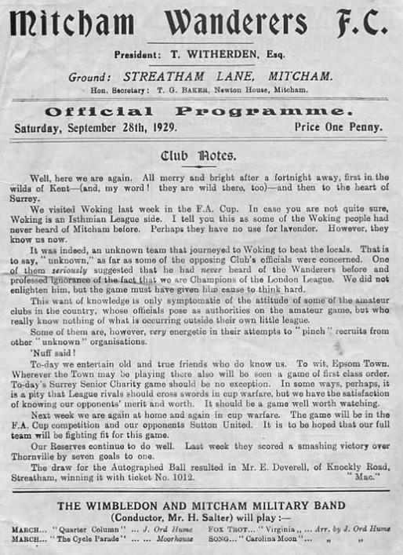
90 years ago today we visited Streatham Lane, the long lost home of Mitcham Wanderers for a Surrey Charity Shield match, but were defeated 2-1 with Wilfred ‘Bronk’ Challis scoring our goal. I have no idea how he got his nickname of Bronk and neither did his niece when I spoke to her about twelve years ago! (see programme left)

As for Mitcham they merged with Tooting Town in 1932, to become Tooting & Mitcham United and moving to Tooting’s Sandy Lane ground at the same time. Streatham Lane is long buried by housing as a result, and so of course is Sandy Lane now!

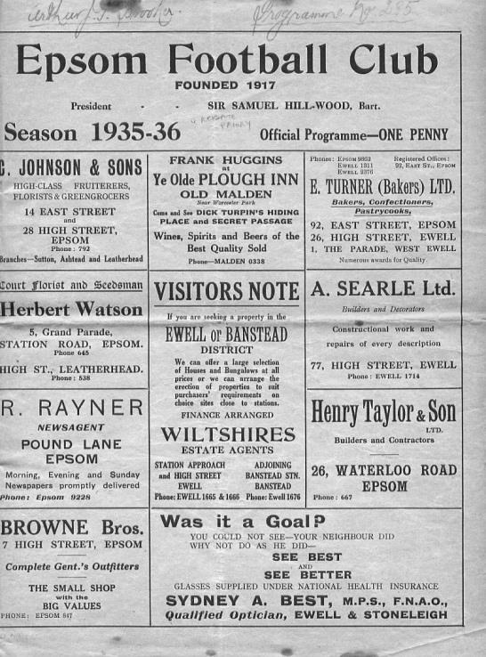
84 years ago today we welcomed Eton Manor and defeated them in a London League match by six goals to three with Jackie Pullen scoring three times. (see programme below)

62 years ago today we visited Kings Head Lane, Byfleet for an Amateur Cup tie with Vickers and won 7-0 with Dave Hermitage scoring four times. Vickers would eventually fold but the ground would continue to be used for many years by the successful BAC (later Bae) Weybridge team up until the late eighties. The site remains today, right next to and just inside the M25 between junction 10 and 11, although you won’t be able to see it as the site never had lights.

10 years ago this week we welcomed Farnborough North End to Merland Rise for an F.A. Vase First Round match, having received an exemption to that stage. We cruised to a 2-0 lead but somehow, five minutes of madness left the scores level and extra time was required before Dale Marvell netted the winner for us.

This would prove to be quite an important goal as it would send us to Moneyfields, AFC Wellington in Somerset and finally Long Buckby in Northamptonshire where we were narrowly defeated in the last 32 of the competition. It was our first appearance at that stage since 1989 and we have not been back there yet.

Match and Ball Sponsorships – 2019/20
Opponent | Date | Match Sponsor | Ball Sponsor
Fleet Spurs | 03/08/19 | Club President - Stella Lamont
Godalming Town | 20/09/19 | Paul Merritt
Tooting Bec | 27/09/19 | EEFC Management Committee
Kennington (FA Vase) | 31/08/19 | Geoff Dyke – celebrating his 70th birthday
AFC Hayes | 21/09/19
Farnham Town | 28/09/19
FC Deportivo Galicia | 19/10/19
Kensington & Ealing Borough | 26/10/19
Sandhurst Town | 09/11/19
Dorking Wanderers Res | 23/11/19
Bedfont & Feltham | 14/12/19
Westside | 28/12/19
British Airways | 11/01/20
Cove | 25/01/20
Ash United | 08/02/20
Chessington & Hook United | 22/02/20
Eversley & California | 21/03/20
Walton & Hersham | 31/03/20 | Tony Foster
Bagshot | 04/04/20 | Nathan Lambert
Jersey Bulls | 13/04/20 | Club President - Stella Lamont
Match sponsorship costs just £60.00!

Sponsorship includes:

Admission, programmes and hospitality for three people.

A full page advert in the programme and mascot for the day (if required).

Also, you get to choose the player of the match, who will receive a prize

If you are interested, just speak to a Committee Member,
or drop me an email at: richard.c.lambert@gmail.com

Combined Counties League – Division One
Saturday, 21st September 2019 - Kick-off 3.00 p.m.
Epsom and Ewell  (Royal Blue & White hoops) | V |  | AFC Hayes  (Green with Red trim)
Squad | NUMBERS |  | Squad
Felix Davies |  |  | Lukasz Jasiorski
Conor Young |  |  | Sammy Adams
Reisse Griffin |  |  | Bruno Manuel
Adam Heagney |  |  | Jordan Musaka
Lloyd Connelly |  |  | Jemel Lizizi
Chris Head |  |  | James Day
Chaz-Lee Martin |  |  | Nathan Dennis
Joe Bonass-Ward |  |  | Jake Edmunds
Louis Chin |  |  | George Harmes
Todd Murphy |  |  | Harry Whiter
© Scott Murphy |  |  | Morrad Jarraz
Sean White |  |  | Shane Kettle
Bobby Bennett |  |  | Raul Radulescu
Jake Robinson |  |  | Trey Pender Brown
Rory Lewis |  |  | Mattie Marques
Ashley Thompson |  |  | Fabio Azizi
Rob Hendry |  |  | David Opong Wiasie
Taryn Smith
Toby Funnell
Jordan Gallagher
Liam Roberts
Billy Carney
Simon Funnell | MANAGER |  | Alan Galloway
 | ASSISTANT |  | Terry Schofield,  James White, Terry Welch
Sam Morgan | COACHES
 | PHYSIO
REFEREE: L.Clark
ASSISTANTS: E.Makola, P.Maskell

OUR NEXT VISITORS TO HIGH ROAD
FC Deportivo Galicia
Combined Counties League – Division One
Saturday, 19th October 2019 – Kick-off – 3.00 p.m.

Combined Counties League – Division One
Saturday, 28th September 2019 - Kick-off 3.00 p.m.
Epsom and Ewell  (Royal Blue & White hoops) | V |  | Farnham Town  (Claret & Blue)
Squad | NUMBERS |  | Squad
Felix Davies |  |  | Romaine Atkinson
Conor Young |  |  | Aaron Buffton
Reisse Griffin |  |  | Tom Bowles
Adam Heagney |  |  | Gavin Brainch
Lloyd Connelly |  |  | Mark Corbett
Chris Head |  |  | Jack Falvey
Chaz-Lee Martin |  |  | James Forster
Joe Bonass-Ward |  |  | Matthew Glass
Louis Chin |  |  | Alfie Harburn
Todd Murphy |  |  | Dease Kerrison (GK)
© Scott Murphy |  |  | Wes Lennon
Sean White |  |  | Jack May
Bobby Bennett |  |  | Jacob McDonald ©
Jake Robinson |  |  | Max Meaton
Rory Lewis |  |  | Jack Mitchell
Ashley Thompson |  |  | Kye Nash
Rob Hendry |  |  | Charlie Oakley
Taryn Smith |  |  | Harry Oakley
Toby Funnell |  |  | Jordan Page
Jordan Gallagher |  |  | Logan Peel
Liam Roberts |  |  | Thomas Reeves
Billy Carney |  |  | Muhammed Sabo
 |  |  | Rowan Sharratt
 |  |  | Joseph Sowden
 |  |  | Otis Taylor
 |  |  | Walter Verkaik
 |  |  | Bruce Wellings
 |  |  | Jordan Westbrook (GK)
 |  |  | Luke Whiddett
Simon Funnell | MANAGER |  | Luke Turkington
 | ASSISTANT |  | Lee Pollard
Sam Morgan | COACHES
 | PHYSIO |  | Andy Sharratt
REFEREE: S.Idris
ASSISTANTS: A.Absolon, to be advised

OUR NEXT VISITORS TO HIGH ROAD
FC Deportivo Galicia
Combined Counties League – Division One
Saturday, 19th October 2019 – Kick-off – 3.00 p.m.

